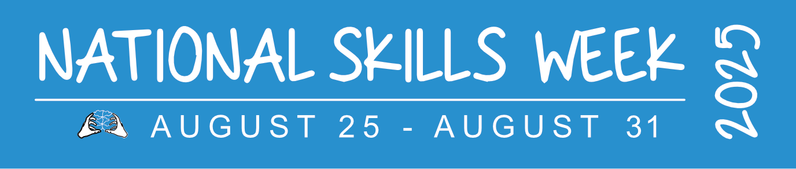
MEDIA RELEASE – For immediate release
NATIONAL SKILLS WEEK 2025: THE ART OF VOCATIONAL SKILLS TRAINING ON SHOW IN WESTERN AUSTRALIA
Explore All The Options and consider Vocational Education and Training (VET)
National Skills Week: 25–31 August 2025
Sydney, 18 August 2025 – National Skills Week 2025 will be officially launched in Western Australia on Wednesday, August 20, at John Curtin College of the Arts in Fremantle.
Jodie Hanns, Parliamentary Secretary to Amber-Jade Sanderson, Minister for Energy and Decarbonisation, Manufacturing, Skills and TAFE, Pilbara, will present the keynote address at the event, which will be a celebration of the power of vocational education and training (VET) to transform careers, communities and the WA economy.
In the past year, the WA Government has made a significant investment in vocational education and training, including $100 million in funding VET in this year’s Budget. Fee settings across fee-free and low-free courses remain the same in 2026 as 2025, which will help boost course enrolments to record highs and meet the workforce needs of the state’s booming economy. Other initiatives the WA Government is funding include the TAFE Modern Equipment Program expansion, with $33.9 million budgeted; the Adult Apprentice Incentive program, to help employers meet the wage gap when employing an apprentice or trainee over the age of 21, with 100 places a year for four years starting in 2025-26; and more than $17 million for the expansion of the Munster Campus of South Metropolitan TAFE.
Meanwhile, latest Jobs and Skills Australia data reveals vocational education and training qualifications have been most sought after by Western Australian employers in the past year, with 58 per cent of jobs requiring a certificate II, certificate III, certificate IV, diploma or advanced diploma. It compares to 32 per cent of jobs requiring a bachelor degree or higher.
The WA National Skills Week 2025 launch will include engaging discussions about skills, VET programs and initiatives with education, industry and government leaders. It will include performances and displays from across John Curtin School of Arts’ students and courses, including dance, media and production, arts and culture, and music and music theatre. John Curtin School of Arts was the gold recipient for the School Pathways to VET Award at the 2024 Australian Training Awards.
Event Date: Wednesday, August 20, 2025
Event Time: 5.30pm to 7.30pm
Event Location: John Curtin College of the Arts, Mia Moorna building, 90 Ellen St, Fremantle
National Skills Week Chair Brian Wexham says:
“I am delighted to be at the John Curtin College of the Arts for the launch of National Skills Week in Western Australia. The Arts play an important role in the development of students’ communication skills, creativity and expression - all of which are highly prized qualities sought by employers, irrespective of what industry or job role is being undertaken.
“National Skills Week plays a pivotal role in raising awareness on the diversity of careers that can be realised through Vocational Education and Training as well as highlighting the skills needs of industry - the jobs now and the jobs of the future.”
Quotes from Industry Providers:
Attributed to Trevor Fairweather, Executive General Manager of Education, ReadyTech
“Supporting National Skills Week aligns with our belief that great technology enables great teaching and learning. We are here to help providers modernise, personalise and deliver skills education at scale.”
Attributed to Lee Xavier, Chief Executive Officer | Apprenticeship Support Australia (ASA)
“As a foundational sponsor, Apprenticeship Support Australia is proud to once again partner with National Skills Week to spotlight the vital role apprenticeships and traineeships play in building meaningful careers. These pathways are essential to developing a skilled, adaptable workforce and we remain committed to supporting individuals and businesses in unlocking their full potential through vocational education and training.”
Attributed to Geordan Murray, Future Workforce & Industry Research, Housing Industry Association
National Skills Week is a vital platform to spark interest in trades and show young Australians just how bright their future can be in building and construction. The demand is real, the work is meaningful, and the opportunities are endless.

WA-based VET success stories available for interviews:
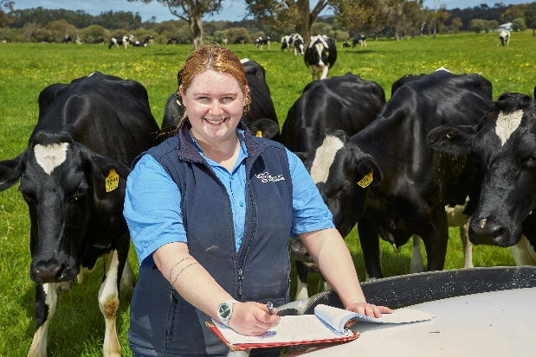
Almira Dall, dairy farm hand and calf rearer
2024 Trainee of the Year, Western Australian Training Awards
Within weeks of completing high school, Almira was working on a dairy farm and discovering a love for practical hands-on work. She soon decided against pursuing her animal science degree at university, instead opting to complete a Certificate III in Agriculture (Dairy Production) traineeship to start becoming qualified for her agriculture career. She then went on to complete a Certificate IV in Agriculture and this year took part in Dairy Australia’s Young Dairy Network study tour in Ireland. “There will always be a need for more people working on farms, as farmers or in other parts of the agricultural sector such as mechanics or electricians,” she says.

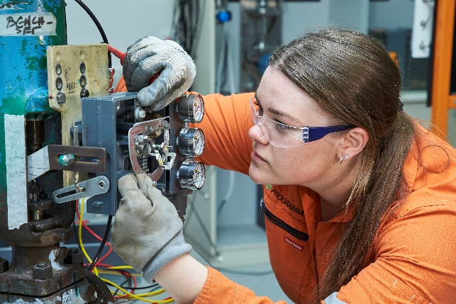
Ellie Wotherspoon, electrician
2024 Apprentice of the Year, Western Australian Training Awards
Ellie’s brother, father and grandfather are all electricians but she had never seen a female electrician so it was never something that she thought she would do. Initially, she started a teaching degree at university after finishing school, but took a break from studies and got practical experience as a nanny for a female electrician. “I remember thinking, ‘Wow if she can do it, maybe I can do it too’. That’s when I pursued an introductory course into what is involved in working in industry, and from there I’ve never looked back,” she says. She pursued a Certificate III in Engineering – Industrial Electrician apprenticeship with a Certificate IV in Instrumentation, giving her a dual trade.
National Skills Week 2025 acknowledges the support provided by the Australian Government, and its major partner, ReadyTech.

Who's Behind National Skills Week?
Supported by the Federal Government (DEWR), State Governments (QLD and NSW), and leading VET organisations, this year’s partners include:
- MEGT
- Apprenticeship Support Australia
- Brick & Block Careers
- Komatsu
- South Australian Skills Commission (SASC)
- Construction Industry Training Board
- TAFE NSW
- Queensland University of Technology
- ReadyTech
- University of Queensland
- Victoria University
- BAE Australia
- Housing Industry Association (HIA)
- Wine Australia
- Adelaide University
- UQ Skills.

Talent Available for Interview:
Media outlets can access interviews with:
- Brian Wexham, Chair, National Skills Week
- VET Alumni & Apprentices of the Year from across Australia
- Industry Leaders & CEOs in healthcare, tech, construction, mining, and more
- Members of the 2025 National Skills Week Advisory Committee
National Skills Week offers facilitated media connections to suit specific sector coverage.

ENDS
Media Contact:
Libby Conway | The Capital Group | libby@capital.com.au | 0439 076 835

Notes to editors:
About National Skills Week 2025
National Skills Week is an annual initiative in Australia, scheduled for 25–31 August 2025, aimed at promoting the value and diversity of Vocational Education and Training (VET). Organised by SkillsOne Television and supported by Australian, State, and Territory Governments, it serves as a platform to highlight career pathways through apprenticeships, traineeships, and other VET programs.
National Skills Week is designed to:
- Raise Awareness: Enhance public understanding of the benefits and opportunities within the VET sector.
- Challenge Perceptions: Dispel outdated myths about VET and showcase its relevance in today's economy.
- Highlight Career Pathways: Demonstrate the diverse career options available through VET, including apprenticeships, full qualifications, micro-credentials, and pathways to higher education.
- Address Skills Shortages: Focus on emerging skills needs and industry trends to support workforce development.
The 2025 theme, “Explore ALL the Options,” encourages individuals to consider a wide range of educational and career pathways, emphasizing opportunities in regional and remote areas, as well as various training formats.
Through over 500 events nationwide, National Skills Week aims to inspire participation in VET, contributing to a skilled and adaptable workforce that meets Australia's evolving economic needs.
For more information or to get involved, visit the official website: nationalskillsweek.com.au.

About ReadyTech – Major sponsor of National Skills Week 2025
ReadyTech (ASX:RDY) is Australia’s leading provider of SaaS for the education, workforce, government, and justice sectors. Focused on enabling outcomes that matter, ReadyTech supports educators with student management, learning management and skills assessment tools tailored to the unique needs of the TAFE, RTO, and tertiary sectors.
More info: readytech.io/education

Jobs and Skills Australia Recruitment Snapshot WA

