
MEDIA RELEASE – For immediate release
VOCATIONAL EDUCATION AND TRAINING: THE SKILLS BACKBONE FOR INDUSTRIES TO THRIVE ACROSS REGIONAL AND REMOTE AUSTRALIA
Explore All The Options and consider Vocational Education and Training (VET)
National Skills Week: 25–31 August 2025
Sydney, 13 August 2025 – Vocational education and training (VET) is the skills backbone for the industries driving regional and remote Australia.
National Skills Week highlights the power of vocational training to give workers the skills required for successful and satisfying careers.
But VET is also key to achieving the skills needs of industries across regional and remote Australia, where job vacancies are growing at faster rates than metropolitan areas.
Health, construction, hospitality and retail are among the largest employing industries requiring VET-qualified staff, including those in shortage such as aged and disabled carers, truck drivers, and electricians.
Mining continues to be a large employer of VET-qualified workers, while the clean energy transformation is creating significant employment opportunities in regional and remote Australia for people trained through VET.
Jobs and Skills Australia states “regional and remote areas have seen a shift in the share of employment towards occupations where VET is the primary pathway in addition to a shift towards highly skilled occupations”.
It also reveals VET students from inner regional, outer regional and remote areas have consistently better training outcomes than their counterparts in major cities. It is in terms of higher rates of completing their qualification as well as having significantly improved employment status after their training.
National Skills Week Chair Brian Wexham commented: "National Skills Week plays a pivotal role in raising awareness on the diversity of careers that can be realised through Vocational Education and Training , highlighting the skills needs of industry , the jobs now and the jobs of the future" Whether you are a high school student or a parent looking to provide guidance to your child, we invite you to use National Skills Week to explore ALL the options available through Vocational Education and Training (VET). Check out Free TAFE courses, investigate Apprenticeship Degree Courses, examine courses and careers that connect to a passion. Delve into the diversity offered through VET, get inspired and discover the many rewarding career pathways and options available that will help ensure young Australians are job ready.
From Industry Providers:
Attributed to:
Trevor Fairweather
Executive General Manager
Education at ReadyTech.

“Skills training builds more than capability – it builds confidence and community.
National Skills Week is a powerful way to recognise that, and we’re excited to be part of
the celebration.”

Attributed to:
Jo Hargreaves
Senior Program Manager
Wine Australia

One of the best aspects of working in wine is the regional communities. You’re not just building a career, but a lifestyle—closer to nature, connected to the land and endless opportunities. Regional areas are crying out for skilled workers in viticulture, trades, hospitality, cellar operations and more.
Attributed to:
Lee Xavier
Chief Executive Officer
Apprenticeship Support Australia (ASA)
National Skills Week 2025 is a celebration of the power of Vocational Education and Training to unlock potential and drive prosperity. This year’s theme, ‘Explore ALL the Options’, highlights the diverse pathways available through VET, from school-based programs to traineeships and apprenticeships, tailored to meet local industry needs.
In regional and remote Australia, apprenticeships and traineeships is more than education - it’s a lifeline for economic growth, job creation, and community resilience. Apprenticeship Support Australia is proud to support initiatives to encourage individuals to discover the rewarding careers that begin with skills-based learning.

VET success story available for interview:
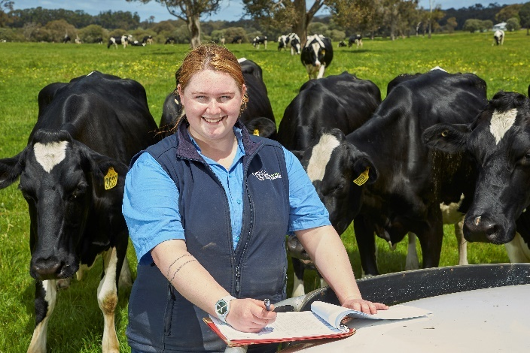
Dairy worker Almira Dall knew she wanted to work with animals when she finished school, so enrolled in an animal science degree at university.
But she decided to defer her studies and take a gap year to gain practical experience with animals and realised she did not need higher education to succeed.
Almira, who was named Trainee of the Year at the 2024 Western Australia Training Awards, studied a Certificate III in Agricultural Dairy Production and then went on to complete a Certificate IV in Agriculture.
“While I was on the farm I realised I was missing the studying aspect of my day-to-day life from high school, so I spoke to my mum and she was suggested I do a TAFE course or something,” she says.
“Once I started working on dairy, I really fell in love with cattle and I was so glad I was able to work, study about them and work with them.”
They discovered she could complete the certificate III traineeship at a dairy, which gave her the knowledge to help her build a career while also ensured she could continue working.
Being paid to learn also helped with the expense of living away from home.
“The reason I moved out of home was to work on a dairy farm and I had the ability to live on my own,” she says.


Harry Roberts, the 2024 QLD Apprentice of the Year, has found his true calling after failing to be accepted in his desired sports science university degree when he finished Year 12.
After briefly working in construction and travelling and working in Europe, he narrowed down what he wanted to get out of a job, searched online and applied for his Certificate III in Aboriculture apprenticeship.
“When I sat down to write what I want to do with my future, I focused on that - I want to be outside, I want to work at heights and I want to be in a team with a strong team focus,” he says.
“I wish there had been someone (at school) telling me (post-school options) weren't just about university and also weren't just about carpentry, plumbing or electrical as the three trades you could do.”
Harry says apprentice wages may not be as good as some other unskilled entry-level roles but being paid to learn and finishing the training with a recognised skill is worth any short-term financial hardship.
“The government offers good incentives as well through the apprenticeship schemes and tool allowance and such that help you get through first year,” he says.
Who's Behind National Skills Week?
Supported by the Federal Government (DEWR), State Governments (QLD and NSW), and leading VET organisations, this year’s partners include:
- MEGT
- Apprenticeship Support Australia
- Brick and Block Careers
- Komatsu
- South Australian Skills Commission (SASC)
- Construction Industry Training Board
- TAFE NSW
- Queensland University of Technology
- ReadyTech
- University of Queensland
- Victoria University
- BAE Australia
- Housing Industry Association (HIA)
- Wine Australia
- Adelaide University
- UQ Skills.
Talent Available for Interview:
Media outlets can access interviews with:
- Brian Wexham, Chair, National Skills Week
- VET Alumni & Apprentices of the Year from across Australia
- Industry Leaders & CEOs in healthcare, tech, construction, mining, and more
- Members of the 2025 National Skills Week Advisory Committee
National Skills Week offers facilitated media connections to suit specific sector coverage.
National Skills Week 2025 acknowledges the support provided by the Australian Government, and its major partner, ReadyTech.
ENDS
Media Contact:
Libby Conway | The Capital Group | libby@capital.com.au | 0439 076 835

Notes to editors:
About National Skills Week 2025
National Skills Week is an annual initiative in Australia, scheduled for 25–31 August 2025, aimed at promoting the value and diversity of Vocational Education and Training (VET). Organised by SkillsOne Television and supported by Australian, State, and Territory Governments, it serves as a platform to highlight career pathways through apprenticeships, traineeships, and other VET programs.
National Skills Week is designed to:
- Raise Awareness: Enhance public understanding of the benefits and opportunities within the VET sector.
- Challenge Perceptions: Dispel outdated myths about VET and showcase its relevance in today's economy.
- Highlight Career Pathways: Demonstrate the diverse career options available through VET, including apprenticeships, full qualifications, micro-credentials, and pathways to higher education.
- Address Skills Shortages: Focus on emerging skills needs and industry trends to support workforce development.
The 2025 theme, “Explore ALL the Options,” encourages individuals to consider a wide range of educational and career pathways, emphasizing opportunities in regional and remote areas, as well as various training formats.
Through over 500 events nationwide, National Skills Week aims to inspire participation in VET, contributing to a skilled and adaptable workforce that meets Australia's evolving economic needs.
For more information or to get involved, visit the official website: nationalskillsweek.com.au.

The Big Skills Challenge Report, Regional Australia Institute
Towards a Regional, Rural and Remote Jobs and Skills Roadmap interim report, Jobs and Skills Australia

