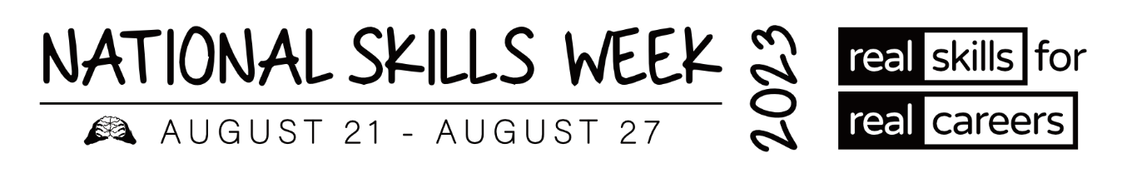

**MEDIA RELEASE – WA VET ALUMNI**

**Vocational Education and Training (VET) Alumni share their inspiring stories and successes**

**for National Skills Week**

**15 August 2023** – As Ambassadors of **National Skills Week**, several VET Alumni from around Australia have won awards and been acknowledged for the high level of training they have achieved in their chosen courses and careers.

Held annually, the vision of **National Skills Week** is to raise awareness on the diversity of careers which can be realised through vocational education and training, the skills for an economically viable future, and the incredible range of new jobs and skills in demand for the future.

**Hear some of their inspiring stories below:**

**Wayne Ryder – Counselling & Mental Health**

* **2022 WA Aboriginal and Torres Strait Islander Student of the Year**
* A person in a black shirt

  Description automatically generated with low confidence **Australian Aboriginal and Torres Strait Islander Student of the Year at the 2022 Australian Training Awards**

From school captain to captain of his football team, Wayne has paved the way for Aboriginal men walking a similar journey. One of his proudest achievements was creating the Waakal Moort Kaadadjiny Festival, a health and wellbeing festival for at-risk Aboriginal people.

In 2012, Wayne started his VET studies in a Certificate II in Surface Extraction Operations. In 2017, Wayne completed a Certificate IV in Mental Health and Diploma in Counselling. He was awarded with an Award of Excellence through Marr Mooditj Training. Wayne has since returned as a keynote speaker to inspire other graduating students. Wayne said, “this made me feel empowered and humbled”.

Wayne is continuously being recognised in the Noongar Community for his hard work and accomplishments. He is an active contributor to Aboriginal Advisory Groups and is Co-chair of Palmerston RAP working group.

Wayne began working for Palmerston Association as a Community Aboriginal Worker, supporting individuals affected by drugs and alcohol following his lived experience. He later won a scholarship to study a Diploma of Leadership and Management with the Australian Institute of Management.

Wayne enjoyed the hands-on approach to learning which ignited his passion to make changes and inspire other people to change their lives for the better. VET has helped Wayne with his own recovery, and he is now a hardworking and motivated individual working in a field he is passionate about. Wayne said, “VET has changed my whole life for the better”.

Wayne’s advice to others is to “always strive for success and chase your dreams! Everyone deserves to love what they do!!”.

Wayne was named the 2022 Western Australian Aboriginal and Torres Strait Islander Student of the Year and Australian Aboriginal and Torres Strait Islander Student of the Year at the 2022 Australian Training Awards.

**ABOUT NATIONAL SKILLS WEEK**

**National Skills Week Chair and Founder, Brian Wexham says** “National Skills Week

designed to achieve real, transformative outcomes for Australian people – to inspire people to undertake active, participative education and training that VET provides resulting in skills that can realise immediate rewards in jobs, success and contribute to building our economy.”

**All you need to know about National Skills Week 2023:**

**When: August 21-27 2023**

**Purpose: To raise awareness of the myriad of rewarding, lucrative and prestigious career pathways available via Vocational Education and Training**

**Key message: A skilled workforce leads to an employed workforce.**

**Interview options / talent:**

**Capital has access to a wide range of Government leaders, CEOs of industry bodies and organisations across industries facing the biggest skills shortages (healthcare, manufacturing, construction etc) as well as more than 15 VET Alumni from all parts of the country who have completed VET courses and won awards.**

**National Skills Week Chairman Brian Wexham is also available for interviews upon request.**

**How to take part in National Skills Week:**

There are a range of options to get involved in National Skills week- from school events, training organisation activities and from industry programs that highlight and promote skills and Vocational training pathways. [Ideas for schools](https://www.nationalskillsweek.com.au/get-involved/schools/ideas-for-schools/), [become a supporter](https://www.nationalskillsweek.com.au/sponsors/), [hold an event and promote it](https://www.nationalskillsweek.com.au/events/) or join in the discussion on social media- [twitter](https://twitter.com/SkillsOne), L[inkedIn](https://www.linkedin.com/skillsone-television), [Facebook](https://www.facebook.com/NationalSkillsWeek), [Instagram](https://www.instagram.com/nationalskillsweek/).

National Skills Week is supported by the Australian Government’s National Careers Institute.

For further information, visit nationalskillsweek.com.au

ENDS

Media Contact

Libby Conway | The Capital Group | [libby@capital.com.au](mailto:libby@capital.com.au) | 0439 076 835