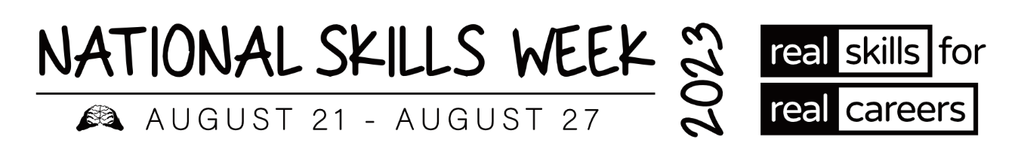

**MEDIA RELEASE – TAS VET ALUMNI**

**Vocational Education and Training (VET) Alumni share their inspiring stories and successes**

**for National Skills Week**

**15 August 2023** – As Ambassadors of **National Skills Week**, several VET Alumni from around Australia have won awards and been acknowledged for the high level of training they have achieved in their chosen courses and careers.

Held annually, the vision of **National Skills Week** is to raise awareness on the diversity of careers which can be realised through vocational education and training, the skills for an economically viable future, and the incredible range of new jobs and skills in demand for the future.

**Hear some of their inspiring stories below:**

**Natasha Robins – Health Care & Social Assistance**

* **2022 Tasmanian Trainee of the year**
* **Finalist at the 2022 Australian Training Awards**

Fresh out of nearly eight years in the hospitality industry Natasha went looking for something different to take a professional step forward in her life. Natasha came to the dental industry by accident. She approached training provider Work & Training about doing a business traineeship but was advised she was over-qualified. Then a chance conversation with one of the consultants provided an entrée to the dental industry where she gained a traineeship with Hopkins Dental. She says her traineeship had the greatest impact on her life – “It challenges me every day and provides the most rewarding feeling at every step.”

Natasha was named the 2022 Tasmanian Trainee of the Year and was a finalist at the 2022 Australian Training Awards.

Natasha said, “**My traineeship challenges me every day and provides the most rewarding feeling at every step**."

**Mathew Fraser, 2022 Tasmania VET Trainer of the Year Finalist – Education & Training; Accommodation & Food Services**

Matt believes that learning is a lifelong journey and applies this philosophy when teaching his hospitality and tourism students at TasTAFE. Matt maintains active industry knowledge and experience to provide a contemporary connection to industry for his students. He also oversees the teams that compete in WorldSkills 2022, Nestle Golden Chef and Australian Culinary Foundation competitions. Matt fosters a love of learning within his students and encourages them to extend themselves. Matt helped his students establish a market garden and business to grow and sell herbs, connecting with the building and facilities students to construct the garden beds and structures.

**ABOUT NATIONAL SKILLS WEEK**

**National Skills Week Chair and Founder, Brian Wexham says** “National Skills Week

designed to achieve real, transformative outcomes for Australian people – to inspire people to undertake active, participative education and training that VET provides resulting in skills that can realise immediate rewards in jobs, success and contribute to building our economy.”

**All you need to know about National Skills Week 2023:**

**When: August 21-27 2023**

**Purpose: To raise awareness of the myriad of rewarding, lucrative and prestigious career pathways available via Vocational Education and Training**

**Key message: A skilled workforce leads to an employed workforce.**

**Interview options / talent:**

**Capital has access to a wide range of Government leaders, CEOs of industry bodies and organisations across industries facing the biggest skills shortages (healthcare, manufacturing, construction etc) as well as more than 15 VET Alumni from all parts of the country who have completed VET courses and won awards.**

**National Skills Week Chairman Brian Wexham is also available for interviews upon request.**

**How to take part in National Skills Week:**

There are a range of options to get involved in National Skills week- from school events, training organisation activities and from industry programs that highlight and promote skills and Vocational training pathways. [Ideas for schools](https://www.nationalskillsweek.com.au/get-involved/schools/ideas-for-schools/), [become a supporter](https://www.nationalskillsweek.com.au/sponsors/), [hold an event and promote it](https://www.nationalskillsweek.com.au/events/) or join in the discussion on social media- [twitter](https://twitter.com/SkillsOne), L[inkedIn](https://www.linkedin.com/skillsone-television), [Facebook](https://www.facebook.com/NationalSkillsWeek), [Instagram](https://www.instagram.com/nationalskillsweek/).

National Skills Week is supported by the Australian Government’s National Careers Institute.

For further information, visit nationalskillsweek.com.au

ENDS

Media Contact

Libby Conway | The Capital Group | [libby@capital.com.au](mailto:libby@capital.com.au) | 0439 076 835