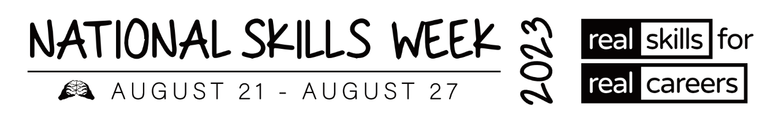

**MEDIA RELEASE – SA VET ALUMNI**

**Vocational Education and Training (VET) Alumni share their inspiring stories and successes**

**for National Skills Week**

**15 August 2023** – As Ambassadors of **National Skills Week**, several VET Alumni from around Australia have won awards and been acknowledged for the high level of training they have achieved in their chosen courses and careers.

Held annually, the vision of **National Skills Week** is to raise awareness on the diversity of careers which can be realised through vocational education and training, the skills for an economically viable future, and the incredible range of new jobs and skills in demand for the future.

**Hear some of their inspiring stories below:**

**Sakina Qambari - Hospitality**

* **2022 SA School-based Apprentice of the Year**
* **2022 Australian School-based Apprentice of the Year at Australian Training Awards**

Sakina migrated to Australia with her family from Pakistan and Afghanistan. She is currently studying Year 11 at Renmark High School, while also working at Renmark Club and has completed a Certificate III in Hospitality. Having only worked in the hospitality industry for a year and a half, Sakina is still exploring her options, however, would like to continue gaining more experience in different sectors of the hospitality industry so she can be better exposed to the opportunities that come with it.

Sakina was named the 2022 South Australian School-based Apprentice of the Year and 2022 Australian School-based Apprentice of the Year at the Australian Training Awards.

**Bhu Chung – Hospitality**

* **2022 SA VET Trainer of the Year at the South Australian Training Awards**
* **Finalist at the 2022 Australian Training Award**
* **TAFE SA honour award**

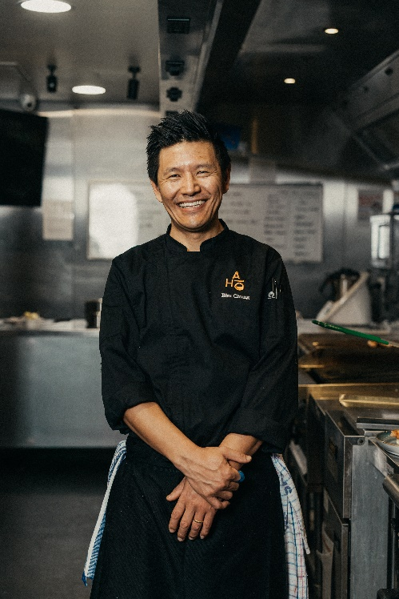

Bhu Chung (he/him) is the Head Trainer and Assessor at the Adelaide Institute of Hospitality, offering hands-on learning and career pathways within South Australia’s hospitality industry. At the age of 14, he left his country of birth, Tibet, to join the Dalai Lama in exile in India and then went on to complete a Bachelor Degree in Political Science at Delhi University. He switched career into the culinary industry at the age of 26, and since 2014, Bhu has been teaching and sharing his passion for food with his students and nurturing them into the next generation of great chefs. In 2019, he attended full-time study in one of the Michelin star schools in France as part of his professional development.

In 2022, Bhu was awarded VET Teacher/Trainer of the Year at the South Australian Training Awards and was a finalist at the 2022 Australian Training Award. Bhu was also presented with a TAFE SA honour award.

**Madison Taylor – Electricity, Gas, Water and Waste Services**

* **2022 SA Vocational Student of the Year**
* **Finalist at the 2022 Australian Training Awards**

Maddy is a rural student completing her Year 12 studies at Burra Community School. Last year, her VET coordinator encouraged students at her school to pick up a trade if they were interested in trying an apprenticeship soon. Maddy advocated for the school to find a trade program which could be run in the local area, providing all students with the opportunity to complete a trade. Maddy’s future aspirations consist of completing her Year 12 studies and obtaining an apprenticeship.

Maddy was named the 2022 South Australian Vocational Student of the Year and was a finalist at the 2022 Australian Training Awards.

**Angelina Dunnett – Health Care and Social Assistance**

* **2022 SA Aboriginal and Torres Strait Islander of the Year**
* **Runner-up for Australian Aboriginal and Torres Strait Islander of the Year at the 2022 Australian Training Awards**

Angelina is an Anangu woman who lives and works in the remote desert communities of the Anangu Pitjantjatjara Yankunytjatjara (APY) lands in the far northwest of SA. “Finding good jobs out here is hard. You need to have good training and education,” Angelina says. Angelina works as a Coordinator with the community patrols program, helping to keep children, young people and communities safe. Angelina has now completed the Certificate II and Certificate III in Community Services through TAFE SA.

Angelina was named the 2022 South Australian Aboriginal and Torres Strait Islander of the Year and Runner-up for Australian Aboriginal and Torres Strait Islander of the Year at the 2022 Australian Training Awards.

**ABOUT NATIONAL SKILLS WEEK**

**National Skills Week Chair and Founder, Brian Wexham says** “National Skills Week

designed to achieve real, transformative outcomes for Australian people – to inspire people to undertake active, participative education and training that VET provides resulting in skills that can realise immediate rewards in jobs, success and contribute to building our economy.”

**All you need to know about National Skills Week 2023:**

**When: August 21-27 2023**

**Purpose: To raise awareness of the myriad of rewarding, lucrative and prestigious career pathways available via Vocational Education and Training**

**Key message: A skilled workforce leads to an employed workforce.**

**Interview options / talent:**

**Capital has access to a wide range of Government leaders, CEOs of industry bodies and organisations across industries facing the biggest skills shortages (healthcare, manufacturing, construction etc) as well as more than 15 VET Alumni from all parts of the country who have completed VET courses and won awards.**

**National Skills Week Chairman Brian Wexham is also available for interviews upon request.**

**How to take part in National Skills Week:**

There are a range of options to get involved in National Skills week- from school events, training organisation activities and from industry programs that highlight and promote skills and Vocational training pathways. [Ideas for schools](https://www.nationalskillsweek.com.au/get-involved/schools/ideas-for-schools/), [become a supporter](https://www.nationalskillsweek.com.au/sponsors/), [hold an event and promote it](https://www.nationalskillsweek.com.au/events/) or join in the discussion on social media- [twitter](https://twitter.com/SkillsOne), L[inkedIn](https://www.linkedin.com/skillsone-television), [Facebook](https://www.facebook.com/NationalSkillsWeek), [Instagram](https://www.instagram.com/nationalskillsweek/).

National Skills Week is supported by the Australian Government’s National Careers Institute.

For further information, visit nationalskillsweek.com.au

ENDS

Media Contact

Libby Conway | The Capital Group | [libby@capital.com.au](mailto:libby@capital.com.au) | 0439 076 835