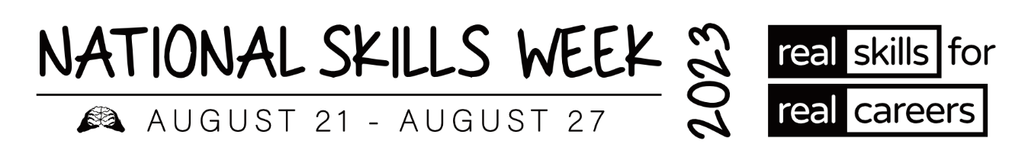

**MEDIA RELEASE – QLD VET ALUMNI**

**Vocational Education and Training (VET) Alumni share their inspiring stories and successes**

**for National Skills Week**

**15 August 2023** – As Ambassadors of **National Skills Week**, several VET Alumni from around Australia have won awards and been acknowledged for the high level of training they have achieved in their chosen courses and careers.

Held annually, the vision of **National Skills Week** is to raise awareness on the diversity of careers which can be realised through vocational education and training, the skills for an economically viable future, and the incredible range of new jobs and skills in demand for the future.

**Hear some of their inspiring stories below:**

**Jennah Halley – Air Conditioning & Refrigeration**

* **2022 QLD Apprentice of the Year**
* **Australian Apprentice of the year at Australian Training Awards**

Jennah's training journey started when her brother, also a refrigeration technician, asked her to help out a few hours a week. From there, Jennah grew a keen interest in the industry and, with the completion of her Certificate III in Air Conditioning and Refrigeration in 2021, she is believed to be the only qualified female refrigeration technician in Cairns – a statistic she's hoping to help change.

Jennah was named the 2022 Queensland Apprentice of the Year and 2022 Australian Apprentice of the Year at the Australian Training Awards.

**ABOUT NATIONAL SKILLS WEEK**

**National Skills Week Chair and Founder, Brian Wexham says** “National Skills Week

designed to achieve real, transformative outcomes for Australian people – to inspire people to undertake active, participative education and training that VET provides resulting in skills that can realise immediate rewards in jobs, success and contribute to building our economy.”

**All you need to know about National Skills Week 2023:**

**When: August 21-27 2023**

**Purpose: To raise awareness of the myriad of rewarding, lucrative and prestigious career pathways available via Vocational Education and Training**

**Key message: A skilled workforce leads to an employed workforce.**

**Interview options / talent:**

**Capital has access to a wide range of Government leaders, CEOs of industry bodies and organisations across industries facing the biggest skills shortages (healthcare, manufacturing, construction etc) as well as more than 15 VET Alumni from all parts of the country who have completed VET courses and won awards.**

**National Skills Week Chairman Brian Wexham is also available for interviews upon request.**

**How to take part in National Skills Week:**

There are a range of options to get involved in National Skills week- from school events, training organisation activities and from industry programs that highlight and promote skills and Vocational training pathways. [Ideas for schools](https://www.nationalskillsweek.com.au/get-involved/schools/ideas-for-schools/), [become a supporter](https://www.nationalskillsweek.com.au/sponsors/), [hold an event and promote it](https://www.nationalskillsweek.com.au/events/) or join in the discussion on social media- [twitter](https://twitter.com/SkillsOne), L[inkedIn](https://www.linkedin.com/skillsone-television), [Facebook](https://www.facebook.com/NationalSkillsWeek), [Instagram](https://www.instagram.com/nationalskillsweek/).

National Skills Week is supported by the Australian Government’s National Careers Institute.

For further information, visit nationalskillsweek.com.au

ENDS

Media Contact

Libby Conway | The Capital Group | [libby@capital.com.au](mailto:libby@capital.com.au) | 0439 076 835