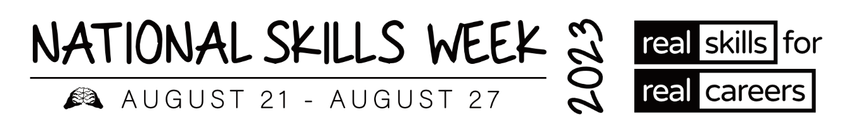

**MEDIA RELEASE – NT VET ALUMNI**

**Vocational Education and Training (VET) Alumni share their inspiring stories and successes**

**for National Skills Week**

**15 August 2023** – As Ambassadors of **National Skills Week**, several VET Alumni from around Australia have won awards and been acknowledged for the high level of training they have achieved in their chosen courses and careers.

Held annually, the vision of **National Skills Week** is to raise awareness on the diversity of careers which can be realised through vocational education and training, the skills for an economically viable future, and the incredible range of new jobs and skills in demand for the future.

**Hear some of their inspiring stories below:**

**Kira Vanderkley, 2022 NT Vocational Student of the Year and Finalist at Australian Training Awards – Arts & Recreation Services**

Since completing her qualification with Charles Darwin University, Kira has gained even more confidence in her communication skills with clients and colleagues. She loves working in a team and has helped many other staff members who have struggled with their workloads. Passionate about inspiring people in their fitness journey, Kira has gained motivation, accountability, and fresh ideas from study to apply to her training as a fitness instructor. With a willingness to give things a go, Kira now has her own registered business name and would like to become a nutritionist to complement her fitness training.

Kira was named the 2022 Northern Territory Vocational Student of the Year and was a finalist at the 2022 Australian Training Awards.

**ABOUT NATIONAL SKILLS WEEK**

**National Skills Week Chair and Founder, Brian Wexham says** “National Skills Week

designed to achieve real, transformative outcomes for Australian people – to inspire people to undertake active, participative education and training that VET provides resulting in skills that can realise immediate rewards in jobs, success and contribute to building our economy.”

**All you need to know about National Skills Week 2023:**

**When: August 21-27 2023**

**Purpose: To raise awareness of the myriad of rewarding, lucrative and prestigious career pathways available via Vocational Education and Training**

**Key message: A skilled workforce leads to an employed workforce.**

**Interview options / talent:**

**Capital has access to a wide range of Government leaders, CEOs of industry bodies and organisations across industries facing the biggest skills shortages (healthcare, manufacturing, construction etc) as well as more than 15 VET Alumni from all parts of the country who have completed VET courses and won awards.**

**National Skills Week Chairman Brian Wexham is also available for interviews upon request.**

**How to take part in National Skills Week:**

There are a range of options to get involved in National Skills week- from school events, training organisation activities and from industry programs that highlight and promote skills and Vocational training pathways. [Ideas for schools](https://www.nationalskillsweek.com.au/get-involved/schools/ideas-for-schools/), [become a supporter](https://www.nationalskillsweek.com.au/sponsors/), [hold an event and promote it](https://www.nationalskillsweek.com.au/events/) or join in the discussion on social media- [twitter](https://twitter.com/SkillsOne), L[inkedIn](https://www.linkedin.com/skillsone-television), [Facebook](https://www.facebook.com/NationalSkillsWeek), [Instagram](https://www.instagram.com/nationalskillsweek/).

National Skills Week is supported by the Australian Government’s National Careers Institute.

For further information, visit nationalskillsweek.com.au

ENDS

Media Contact

Libby Conway | The Capital Group | [libby@capital.com.au](mailto:libby@capital.com.au) | 0439 076 835