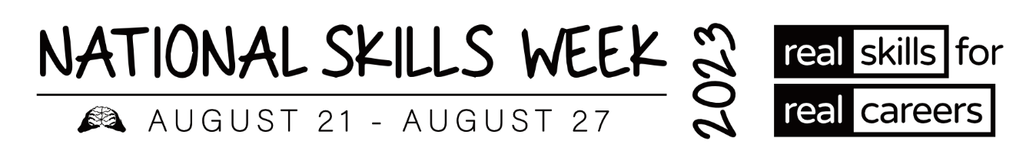

**MEDIA RELEASE – ACT VET ALUMNI**

**Vocational Education and Training (VET) Alumni share their inspiring stories and successes**

**for National Skills Week**

**15 August 2023** – As Ambassadors of **National Skills Week**, several VET Alumni from around Australia have won awards and been acknowledged for the high level of training they have achieved in their chosen courses and careers.

Held annually, the vision of **National Skills Week** is to raise awareness on the diversity of careers which can be realised through vocational education and training, the skills for an economically viable future, and the incredible range of new jobs and skills in demand for the future.

**Hear some of their inspiring stories below:**

**Frances Zewe, 2022 ACT Trainee of the Year – Public Administration and Safety**

Frances graduated from the University of Sydney with a Doctor of Veterinary Medicine in December 2020. She worked for 6 years in invasive species management and the devastating impact on Australian biodiversity. Wanting to dive deeper into humane methods for controlling invasive animals and contribute more broadly to the field of animal welfare, Frances was drawn to the Australian Public Service but was unsure about pursuing a non-clinical veterinary career.

Frances was named the 2022 ACT Trainee of the Year and was a finalist at the 2022 Australian Training Awards.

Frances said: “***The VET pathway changed my life as it helped me to bridge the gap between my veterinary clinical training and applying these skills to a public service career.”***

**Julia Ware, 2022 ACT Vocational Student of the Year – Health Care and Social Assistance**



Julia thrives in providing language access and therefore choice and independence to the deaf community. She explains she fell in love with the language and has developed strong connections within the deaf community. Real world practice enables her to build relationships with deaf people in the ACT community and build local knowledge and signs. It also builds trust which is key for deaf people who have a limited pool of interpreters and often need help for sensitive or confidential matters. Julia’s goal is to become an Auslan interpreter by completing the Diploma of Interpreting.

Julia was named the 2022 ACT Vocational Student of the Year and was a finalist at the 2022 Australian Training Awards.

**ABOUT NATIONAL SKILLS WEEK**

**National Skills Week Chair and Founder, Brian Wexham says** “National Skills Week

designed to achieve real, transformative outcomes for Australian people – to inspire people to undertake active, participative education and training that VET provides resulting in skills that can realise immediate rewards in jobs, success and contribute to building our economy.”

**All you need to know about National Skills Week 2023:**

**When: August 21-27 2023**

**Purpose: To raise awareness of the myriad of rewarding, lucrative and prestigious career pathways available via Vocational Education and Training**

**Key message: A skilled workforce leads to an employed workforce.**

**Interview options / talent:**

**Capital has access to a wide range of Government leaders, CEOs of industry bodies and organisations across industries facing the biggest skills shortages (healthcare, manufacturing, construction etc) as well as more than 15 VET Alumni from all parts of the country who have completed VET courses and won awards.**

**National Skills Week Chairman Brian Wexham is also available for interviews upon request.**

**How to take part in National Skills Week:**

There are a range of options to get involved in National Skills week- from school events, training organisation activities and from industry programs that highlight and promote skills and Vocational training pathways. [Ideas for schools](https://www.nationalskillsweek.com.au/get-involved/schools/ideas-for-schools/), [become a supporter](https://www.nationalskillsweek.com.au/sponsors/), [hold an event and promote it](https://www.nationalskillsweek.com.au/events/) or join in the discussion on social media- [twitter](https://twitter.com/SkillsOne), L[inkedIn](https://www.linkedin.com/skillsone-television), [Facebook](https://www.facebook.com/NationalSkillsWeek), [Instagram](https://www.instagram.com/nationalskillsweek/).

National Skills Week is supported by the Australian Government’s National Careers Institute.

For further information, visit nationalskillsweek.com.au

ENDS

Media Contact

Libby Conway | The Capital Group | [libby@capital.com.au](mailto:libby@capital.com.au) | 0439 076 835